Remote Area Medical Health Expedition 2018
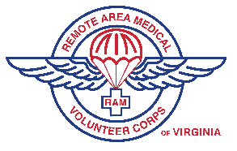
July 20, 21 & 22, 2018
Exhibitor Registration

Please mail or fax completed form to:
The Health Wagon
PO Box 7070 Wise, VA 24293
Phone-276.328.8850 || Fax-276.328.8853
www.thehealthwagon.org
Exhibitor Name:

PLEASE NOTE:
- All those participating as a vender will also need to register as Health Resource with RAM at volunteer.ramusa.org
- Tables and chairs are limited; please bring your own.
- Requests can be made, but due to limitations beyond our control we may or may not be able to accommodate them. Requests must be made before the event.
- Due to limited space availability, requests will be reviewed by the organizing committee prior to the event for approval.
- Priority space may be allocated to those that commit to all three days.
- Space assignments are made and due to circumstances beyond our control we reserve the right to move you.
Description of services being provided:
Contact Person(s):
Address:
Phone:
Fax:
Email:
Website:
Please verify the day(s) your organization will participate:

______July 20 (Friday)
______July 21 (Saturday)
______July 22 (Sunday)
Special needs or requirements:

